

**POLICY BRIEF**

**FORCED LABOUR INDICATORS: ANALYSIS REPORT OF**

**MIGRANT WORKERS CASE STUDIES IN THAI FISHERIES SECTOR**

**©SEPTEMBER 2024**

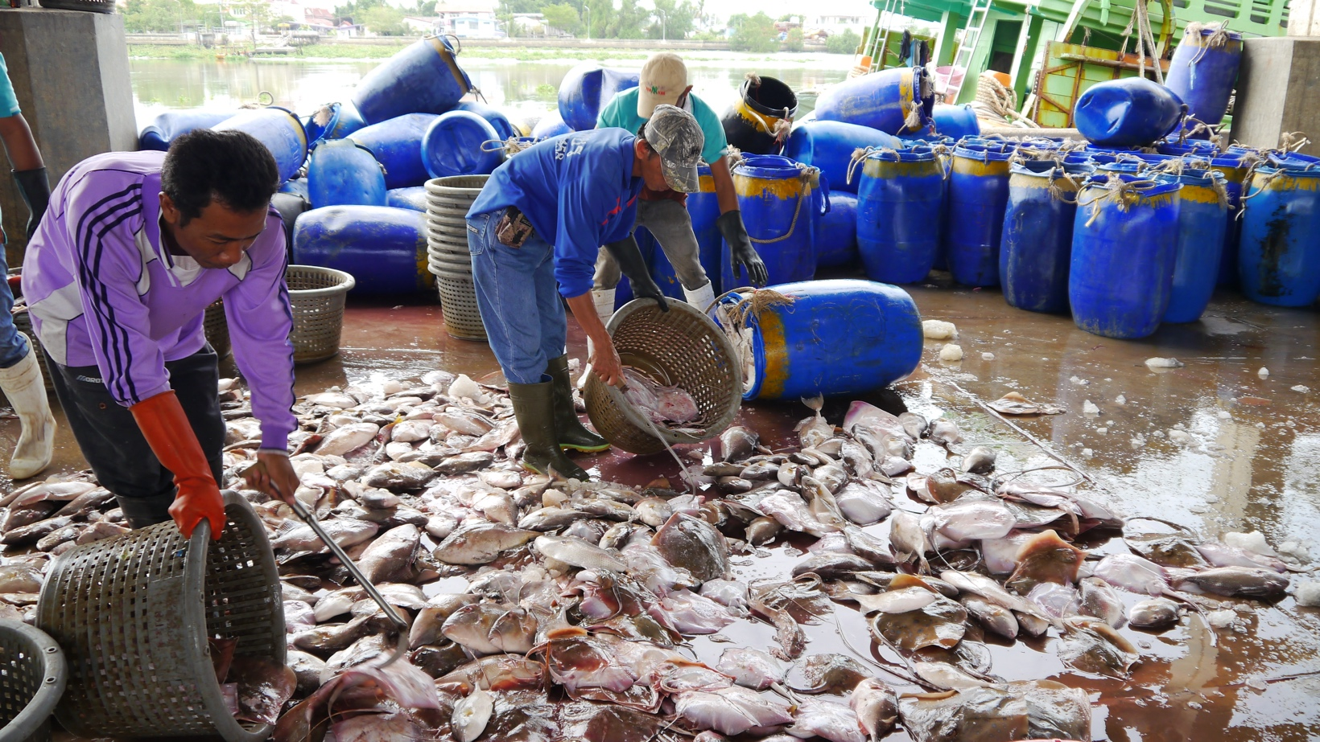

© Jeanne Mariehallacy

**INTRODUCTION**

Thailand has ratified two core treaties of the International Labour Organization (ILO) concerning the eradication of forced labour: (1) the Forced Labour Convention, 1930 (No. 29), ratified on 26 February 1969, and (2) the Abolition of Forced Labour Convention, 1957 (No. 105), ratified on 2 December 1969. Additionally, Thailand ratified the Protocol of 2014 to the Forced Labour Convention 1930 on 4 June 2018, which outlines detailed measures for the prevention and suppression of forced and compulsory labour, aligning them with the current situation and forms of forced labour. This ratification has led to significant reforms in laws and practices in Thailand.

This report has been made possible with the support of civil society organisations (CSOs) that offer legal assistance to Thai and migrant workers. The report aims to analyse whether labour conditions in the fisheries and fisheries-related sectors are vulnerable to forced labour and proposes strategies for preventing and addressing such risks. The analysis draws on data from over 30 case studies conducted by CSOs from 2020 to 2024, focusing on their work assisting migrant workers in these sectors. The research explores information from documented cases, related documents, other evidence, and consultations with those involved in providing legal assistance. The analysis is based on the ILO’s forced labour indicators.

The findings of this study were presented during the workshop “Protection in the Fisheries Sector: Exploring Challenges, Enhancing Knowledge, and Ways to Further Collaborate,” held on 14-15 May 2024 at the Amari Don Muang Airport Hotel in Bangkok. The workshop was attended by representatives from government agencies, the ILO, the private sector, academia, and CSOs. The information, opinions, and input from the participants are compiled in this report.

**FINDINGS FROM THE CASE STUDIES**

This report examines facts from 30 case studies using an analytical framework based on the 11 ILO indicators of forced labour: abuse of vulnerability, deception, restriction of movement, isolation, physical and sexual violence, intimidation and threats, retention of identity documents, withholding of wages, debt bondage, abusive working and living conditions, and excessive overtime. The case studies are categorised into five groups as follows:

**▸** **Case Study Group 1: Definite Use of Forced Labour or Trafficking in Persons**

This group includes 3 cases where forced labour indicators were evident throughout the recruitment and employment processes, including preventing workers from resigning. These cases involved clear violations of multiple laws.

**▸** **Case Study Group 2: Strong to Definite Use of Forced Labour or Trafficking in Persons**

This group also includes 3 cases, where multiple forced labour indicators were present during the employment process, particularly in preventing workers from resigning. However, no clear indicators were found during recruitment. Offences against multiple legal provisions, including physical abuse as per the Penal Code, were also identified in these cases.

**▸ Case Study Group 3: Likely Use of Forced Labour or Trafficking in Persons**

This group comprises 6 cases with strong indicators of forced labour (2 indicators), similar to Groups 1 and 2, but with less clarity. These cases warrant careful monitoring as further legal violations could escalate them into more serious cases of forced labour. Indicators were primarily identified during the employment process and in preventing workers from resigning.

**▸** **Case Study Group 4: Possible Use of Forced Labour**

This group includes 7 cases, mostly involving breaches of labour protection laws. In these cases, the forced labour indicators are less clear, particularly during the termination of employment.

**▸Case Study Group 5: Possible Use of Forced Labour (Work-Related Injury)**

This group includes 11 cases involving work-related injuries or hazards. These cases relate to forced labour indicators concerning abusive working and living conditions on fishing vessels and in fisheries-related workplaces.

**THE SITUATION OF FORCED LABOUR ACCORDING TO THE ILO FORCED LABOUR INDICATORS**

Findings from the case studies indicate that nearly half align with the ILO's forced labour indicators, leading to repeated labour rights violations.

In clear cases of forced labour, indicators were present at every stage—from recruitment to employment, and especially during resignation or job changes. These indicators were especially evident when workers attempted to leave their jobs. These cases often involved brokers and physical abuse. Despite victim screening and legal prosecutions being initiated in all the cases documented in this report, none of the defendants were convicted of forced labour offences by the Court. This was due to challenges related to legal interpretation, the availability and quality of evidence, and the testimony of plaintiffs, witnesses, and expert witnesses. The Court’s interpretation of certain issues, such as the retention of identity documents by employers or their voluntary surrender by employees, was complicated by ambiguities in legal provisions and practices.

Cases deemed highly likely to involve forced labour often included repeated offences, such as wage withholding and document retention, which frequently occurred during employment and when employees attempted to quit their jobs.

In cases considered likely to involve forced labour, at least one indicator was present, usually emerging when employees were about to resign or change jobs. These violations, often involving wage withholding and document retention, escalated to disputes after employment termination. The most common issues were wage withholding and document retention, although these were not always identified or reported during inspections of fishing vessels.

© Jeanne Mariehallacy

Work-related injuries and hazards were among the most common issues observed in the case studies. While not directly indicating forced labour, they were linked to abusive working conditions, lack of accident prevention, and inadequate medical treatment. Serious incidents included the loss of limbs or death as a result of work-related accidents. Although many of these cases fell into Groups 4 and 5, and did not exhibit strong indicators of forced labour, they nevertheless highlight the inefficacies of law enforcement in ensuring labour protection, which can lead to labour rights violations. If such cases involve multiple indicators or breaches of various legal provisions, they may escalate to situations involving forced labour.

The case studies reveal that forced labour indicators often appeared when workers attempted to quit their jobs, particularly in relation to document retention and wage withholding. These circumstances complicate the establishment of facts and pose a challenge in determining whether such cases involve forced labour under Section 6/1 of the Anti-Trafficking in Persons Act B.E. 2551 and its amendments.

**CHALLENGES REGARDING LEGAL ACTION IN CASES INVOLVING FORCED LABOUR INDICATORS**

In case studies likely to involve forced labour, several challenges to legal action have been identified. These include protracted legal proceedings, the burden on and readiness of employees to engage with the justice process, language barriers and interpretation issues, difficulties in acquiring and compiling evidence, varying interpretations of the law, the weighing of evidence provided by employees versus that of suspects, local influence exerted by employers or suspects, and the presentation of evidence necessary to establish the elements of forced labour offences.

Regarding other rights violations, such as the withholding of wages and physical abuse—both critical indicators of forced labour—key challenges include the compilation of evidence and how the court weighs such evidence. Additionally, at the investigation level, mediation is often preferred over prosecution, particularly in cases involving the withholding of employees’ identity documents and issues related to brokers.

These challenges may help explain why, to date, there have been no convictions of suspects involved in offences related to forced labour or services, and why there has been ineffective enforcement of laws concerning the ILO’s forced labour indicators. This lack of enforcement leaves ongoing risks of forced labour within the working conditions in the fisheries sector.

**FACTORS CONTRIBUTING TO FORCED LABOUR RISK**

Key factors perpetuating forced labour risk include the vulnerabilities of migrant workers in Thailand, particularly in the fisheries sector. Migrant workers on fishing vessels are more vulnerable than their onshore counterparts, facing harsher living and working conditions. Hazardous conditions on board also lead to a higher incidence of work-related injuries, including serious accidents.

The screening process for forced labour victims is another critical factor. Limited coordination among agencies and inadequate skills within multidisciplinary teams hinder the effective identification of victims.

The interpretation of laws concerning forced labour is also critical. A common issue involves distinguishing between document retention and voluntary document entrusting. Disputes often arise when employers refuse to return documents that employees had entrusted to them, an issue present in over half of the case studies.

Regarding the interpretation of restriction of freedom of movement, there have been legal precedents that the Court ruled that the employees who were migrant workers were still able to communicate, travel and use their phones, and therefore, they were not subject to restriction of freedom of movement while leaving out relevant contexts.

For example, when employers withhold identity documents or workers incur debts to their employers, it becomes nearly impossible for them to change jobs. Additionally, legal requirements for obtaining work permits and residency in Thailand further restrict their ability to seek alternative employment.

The interpretation of physical violence or abuse also presents challenges, particularly in determining whether incidents stem from personal conflicts or are work-related. The difficulty in obtaining clear evidence further complicates establishing intent.

Similarly, the interpretation of intimidation and wage withholding is challenging due to the difficulty in acquiring evidence and proving intent. These compartmentalized legal interpretations contribute to instances of forced labour that are not adequately addressed through a holistic approach.

**JUSTICE PROCESS IN PROSECUTING FORCED LABOUR**

Migrant workers face numerous obstacles in accessing justice, including a lack of unionization, and organizing, which results in inadequate rights protection and awareness. Legal complexities, such as the need to navigate multiple authorities and burdensome documentation requirements, further hinder their ability to seek justice. Case studies also reveal that fear of employers and public officials often discourages workers from pursuing legal action. Additionally, the difficulty in compiling evidence presents a significant barrier to successful prosecution.

**WORK-RELATED INJURIES AND HAZARDS**

While work-related injuries and hazards are not directly linked to forced labour indicators, they often correlate with abusive living and working conditions. According to case studies, these issues are prevalent and warrant urgent attention. The severity of injuries is often related to delays in medical treatment, as workers on fishing vessels are frequently far from shore, and decisions to seek medical attention are critical for their safety.

Under the Workmen's Compensation Fund Act B.E. 2537, employers are required to register their fisheries workers with the Workmen's Compensation Fund (WCF). However, many workers remain unregistered, and employers often fail to pay WCF contributions. Additionally, when migrant workers die while working at sea, their overseas descendants struggle to access WCF benefits in Thailand.

Another challenge arises from the failure to report work-related injuries. When injured workers seek medical care, employers often do not notify authorities that the injuries are work-related, leading to incomplete occupational health documentation. This affects the enforcement of the Occupational Safety, Health and Environment Act B.E. 2554, the recording of statistics by the Social Security Office, and the disbursement of WCF funds for medical treatment. Consequently, workers may be deprived of their rightful benefits, and public authorities may lack the information needed to improve safety conditions on fishing vessels.

**RECOMMENDATIONS**

This part compiles recommendations for concerned agencies to enhance labour rights protection and effective legal enforcement as well as sustainability in fisheries industry.

1. **Interpretation of Forced Labour Offences under Section 6/1 of the Anti-Trafficking in Persons Act B.E. 2551 and the Victim Screening Process under the National Referral Mechanism (NRM)**
   1. Enhancing Law Enforcement: Law enforcement agencies, including inquiry officials, prosecutors, and judges, should receive guidance on interpreting forced labour offences under Section 6/1 of the Anti-Trafficking in Persons Act. This should include consideration of the ILO’s forced labour indicators and the specific context of migrant workers in Thailand’s fisheries sector. Given the ongoing use of forced labour in the sector, it is crucial to ensure that these factors are considered in prosecutions and adjudications, where convictions have been rare.
   2. Clarity in Coercion Methods: The Ministry of Labour and other concerned agencies should develop clear guidelines on interpreting coercion methods, such as identity document retention and debt bondage, under Section 6/1. These guidelines should align with ILO standards and be widely communicated to raise awareness among relevant parties.
   3. Revising Victim Screening Processes: The Ministry of Social Development and Human Security should revise the trafficking and forced labour victim screening process to better identify and protect vulnerable individuals. The focus should shift from fact-gathering for prosecution to prioritizing the protection of injured or potentially injured parties. Multidisciplinary teams, composed of various public authorities, should be involved to avoid re-traumatizing victims during the fact-finding process.
   4. Protection Based on Vulnerabilities: The Ministry of Social Development and Human Security and the Ministry of Labour should ensure that protection for injured or potential victims meets their needs, i.e., by offering them statuses and rights to reside and work regardless of the identified victim status, but rather based on their vulnerabilities and rights violations against them.
2. **Withholding of Employees' Identity Documents and Wage Deductions** 
   1. The Ministry of Labour, through the Department of Employment (DoE) and other concerned agencies, should actively prosecute employers or individuals who withhold employees' identity documents, in accordance with Section 131 of the Foreigners' Working Management Emergency Decree, B.E. 2560. Clear guidelines should be developed to help identify and address document withholding, fostering proper understanding among all stakeholders.
   2. The Ministry of Labour, through the Department of Labour Protection and Welfare, should raise awareness about wage deductions and create tools to promote common understanding between employees and employers. This includes providing a payment slip template and a list of legally deductible and non-deductible items. These documents can serve as evidence in disputes and help ensure compliance with Section 49 of the Foreigners' Working Management Emergency Decree, B.E. 2560. Authorities should strictly enforce penalties for illegal wage deductions.
   3. Labour inspectors should be supported in conducting thorough inspections and should coordinate with inquiry officials when employers use employees' financial statements or ATM cards without their knowledge or permission, as this constitutes an offence under the Penal Code and other laws.

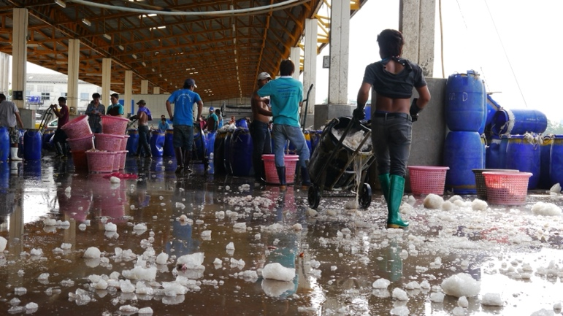

© Jeanne Mariehallacy

1. **Work-Related Injuries and Hazards** 
   1. The Ministry of Labour, along with the multidisciplinary team responsible for fishing vessel inspections, should enforce stringent safety measures on board fishing vessels, in compliance with the Occupational Safety, Health and Environment Act B.E. 2554. This includes ensuring proper training (Section 16), displaying warning symbols and safety signs (Section 17), and mandating the use of personal protective equipment (Section 22). Clear guidelines should be developed to help employers and employees prevent accidents, aligning with their duties under relevant laws.
   2. The Ministry of Labour, Harbour Department, and Department of Fisheries should create guidelines for labour inspectors and Port-in Port-out (PIPO) officers to collaborate with inquiry officials when investigating work-related injuries and hazards on fishing vessels. Guidelines should also cover legal proceedings under the Occupational Safety, Health and Environment Act B.E. 2554 and related laws. All cases of death, disappearance, or suicide must be thoroughly investigated, with authorities, not just the injured parties or their families, leading the investigation.
   3. The Port-in Port-out Control Centers (PIPO) and the Social Security Office (SSO) should compile statistics to assess risks, develop preventive measures, and enforce laws to reduce accidents and illnesses. Employers and employees should be involved in offering solutions and improving working conditions on fishing vessels.
   4. Officers of the multidisciplinary team in charge of fishing vessel inspection and the labour inspectors should develop guidelines on how to coordinate with officers of the Social Security Office and how to notify relatives of the injured parties and to offer assist them to have access to all benefits from the Social Security Fund, the Workmen's Compensation Fund, and other private insurances in case of work-related injuries or sickness. An effort should also be made to ensure the fishers’ descendants be entitled to benefits from the insurances rather than the employers or non-related persons in case the employers have purchased insurance policies for the fishers.
   5. The Ministry of Labour, through the Department of Labour Protection and Welfare and the Social Security Office, should review employer contributions to the Social Security Fund and Workmen's Compensation Fund. They should also monitor reports of work-related injuries, hazards, or sicknesses and take strict legal action against employers who violate the law.
2. **Protection of Labour in the Fisheries Sector: Areas for Improvement** 
   1. The multidisciplinary team and labour inspectors should develop methods to monitor employees' working hours and rest periods on fishing vessels, ensuring compliance with legal regulations. Due to the nature of work on fishing vessels, it is challenging to clearly define working hours and rest times, making this a critical area for oversight.
   2. Fishing vessel inspection teams should prioritize identifying forced labour indicators, especially among employers with a history of violations. Pre-departure inspections should include assessing risk factors and conducting drug tests to prevent forced labour on board.
   3. The Port-in Port-out (PIPO) Control Centers should act as a clearinghouse for statistics, assessing risks and developing guidelines to prevent labour rights violations, particularly forced labour, on fishing vessels.
3. **Enhancement of Employees and Their Networking** 
   1. Labour inspectors or civil society should provide regular training to raise awareness among employees about their legal rights, social security benefits, workmen’s compensation, and other entitlements. The training should focus on common issues leading to rights violations, evidence collection for disputes, and the legal duties of employees in the fisheries sector.
   2. The Ministry of Labour should encourage fisheries sector employees to form organizations and participate in the tripartite system. Regular activities should be promoted to ensure employees can contribute to improving working conditions and offer recommendations for law and policy reforms, in line with ILO Conventions No. 87 and 98 on Freedom of Association and Collective Bargaining.
   3. Collaboration between civil society and public authorities should be strengthened to protect labour rights in the fisheries sector, enhance access to justice for fishers whose rights have been violated, and promote information exchange among stakeholders.

**ACKNOWLEDGEMENT**

The case studies in this report are based on information from civil society organizations, including HRDF chapters in Bangkok, Samut Sakhon, and Phuket, Stella Maris Center in Songkhla, and Raks Thai Foundation. HRDF thanks all contributors for their invaluable support and coordination. To protect personal data, informants' names are withheld.

Initial findings were presented at the workshop “Protection in the Fisheries Sector: Exploring Challenges, Enhancing Knowledge, and Collaboration” on 14-15 May 2024 at the Amari Don Muang Airport Hotel, Bangkok. The event gathered feedback from representatives of the Ministry of Labour, Department of Special Investigation, Anti-Trafficking in Persons Division, Immigration Bureau, Migrant Working Group, International Justice Mission, Environmental Justice Foundation, Raks Thai Foundation, The Freedom Fund, Solidarity Center, and Labour Rights Foundation.

HRDF extends gratitude to all workers who provided information. Your commitment to human rights and justice is a driving force for systemic change in policies, laws, and practices that will strengthen workers' rights protection

|  |
| --- |
| **POLICY BRIEF**  **FORCED LABOUR INDICATORS: ANALYSIS REPORT OF MIGRANT WORKERS CASE STUDIES IN THAI FISHERIES SECTOR**  **Published by:** Human Rights and Development Foundation (HRDF)  **Published Online:** Bangkok, September 2024  **Author:** Sopit cheevapanich  **Editors:** Phenpiccha Jankomol and Polwish Subsrisunjai  **Co-Editors**: Human Rights and Development Foundation, Bangkok, Samut Sakhon, and Phuket Offices  **Cover Design**: Veerawat Kamkom  **Translation:** Pipob Udomittipong  This report has been produced by the Human Rights and Development Foundation with support from the Ship to Shore Rights South East Asia Programme, operated by the International Labour Organization (ILO)  and funded by the European Union (EU). The opinions expressed in this report are those of the author and do not reflect the views of the European Union or the International Labour Organization. |