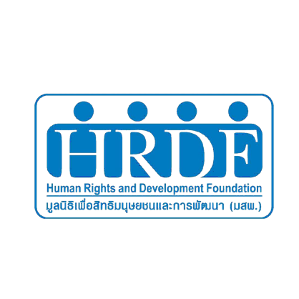
Job Title: Program Manager
Location: Bangkok, Thailand
Deadline: 15 November 2024

Background of the Human Rights and Development Foundation (HRDF):
The Human Rights and Development Foundation (HRDF) is a non-profit organization founded by human rights activists and lawyers, dedicated to promoting and protecting the human rights, democracy, and peace of migrant workers, particularly those from neighboring countries.
Headquartered in Bangkok, HRDF operates legal advocacy offices in Chiang Mai, Mae Sot (Tak), Mahachai (Samut Sakhon), and Phuket. These offices provide legal support to migrant workers and advocate for their rights. HRDF focuses on educating migrant workers about fundamental labor rights and providing legal assistance in cases of forced labor and other labor rights violations. The foundation collaborates with various international partners to advocate for labor protection, freedom of association, and mobility for migrant workers.
HRDF is seeking a motivated and skilled professional to manage programs and contribute to advancing human rights, social equity, and empowerment.

Position Summary:
As the Program Manager, you will play a leadership role in managing HRDF’s program portfolio across five chapters: Bangkok, Chiang Mai, Mae Sot (Tak), Samut Sakhon, and Phuket. Your responsibilities will include supporting the implementation of ongoing projects, developing new project proposals, and coordinating with project teams, funders, and external stakeholders. Based in HRDF’s Bangkok office, you will assist the Program Director in delivering multi-funder programs, supporting financial and operational management, and ensuring project success. Extensive travel to field offices and project sites will be required.

Key Responsibilities:
- Project Management: Lead and support the implementation of HRDF projects across Thailand, ensuring all deliverables are met. Monitor project activities and outcomes to ensure impact.
- Reporting & Feedback: Prepare reports, consult with project coordinators, and provide feedback on project progress. Recommend strategies to improve project efficiency and effectiveness.
- Grant Development: Develop project proposals to secure new funding and liaise with funders to maintain partnerships.

Coordination & Management:
- Collaborate with HRDF teams in Bangkok, Samut Sakhon, Chiang Mai, Mae Sot (Tak), and Phuket to monitor project results and support implementation.
- Serve as a focal point for overseeing the implementation of specific projects.
- Coordinate with the Program Director and Finance Department on strategy development, activity planning, and budget tracking.
- Represent HRDF at meetings, workshops, and public events to advocate for its work and mission.

Required Qualifications, Competencies, and Experience:
- Education: University degree in Social Sciences, Economics, Law, or a related field.
- Experience: At least 5 years of relevant work experience in program management, project coordination, M&E, or related roles.
- Skills:
  - Strong organizational skills with attention to detail and the ability to manage multiple tasks simultaneously.
  - Highly developed interpersonal skills with the ability to build strong relationships with diverse stakeholders.
  - Effective problem-solving, time management, and adaptability.
  - Open-minded, humble, a good listener, and willing to learn and adapt. Positive attitude with a high level of initiative.
  - Strong data collection, analysis, and report writing skills.
  - Advanced communication and writing skills in English.
  - Proficiency in Microsoft Office (Word, Excel, PowerPoint).
- Commitment: Dedication to HRDF’s core values of empathy, empowerment, integrity, accountability, teamwork, and resilience.

Language Skills:
- Native Thai speaker.
- Fluency in spoken and written English.

Duty Station and Timeframe:
- Based in Bangkok, Thailand.
- Requires a mix of office work and field visits.
- Full-time position.
- Immediate start.
- Initial one-year contract with the possibility of extension.

Employee Benefits:
- Social Security Fund.
- Group Insurance.
- Provident Fund.

Application Process:
Interested candidates are invited to submit the following documents via email to info@hrdfoundation.org:
- A cover letter describing your reasons for applying, relevant qualifications, preferred start date, and expected salary.
- A CV with contact information for two references.
- Samples of relevant past work or writing samples.
Please include “Program Manager” and your name in the subject line of the email. HRDF thanks all applicants for their interest; however, only shortlisted candidates will be contacted.
Application Deadline: 15 November 2024.

